**Polars Descriptive Statistics Report**

Here are the first six rows of the data set, which contains all Robert De Niro movies, their Rotten Tomatoes scores, and their years of release:

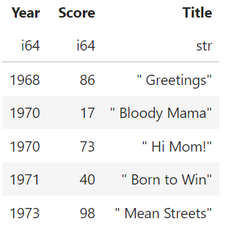

Here are the descriptive statistics of the Rotten Tomatoes scores, as computed by the denirostats() function in main.py:

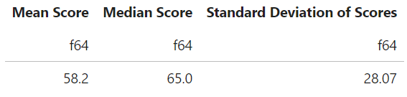

Finally, here is the data visualization, a histogram of the Rotten Tomatoes scores, as generated by the denirohist() function in main.py:

